BUSINESS DATA REPORT: Strategic Insights into Customer Retention
To: Management Board / Marketing Department
From: Data Analysis Team
Subject: Analyzing Key Drivers of Churn and Predictive Retention Strategies

1. EXECUTIVE SUMMARY
Analysis of the current customer base reveals a 26.5% churn rate, which represents a significant risk to Monthly Recurring Revenue (MRR). The primary objective of this project was to identify high-risk segments and deploy a predictive model to intervene before customers leave. Key findings suggest that Contract Type and Internet Service technology are the strongest predictors of churn.

2. KEY PERFORMANCE INDICATORS (KPIs)
Total Customer Base: 7,043
Current Churn Rate: 26.5%
Retention Rate: 73.5%
Primary Risk Segment: Month-to-month contract users with Fiber Optic service.

3. CORE INSIGHTS & ANALYSIS

3.1. Customer Lifecycle and Financial Impact
Data indicates that the risk of churn is highest during the first 6–12 months of the customer journey. Furthermore, there is a direct correlation between high Monthly Charges and the likelihood of cancellation.
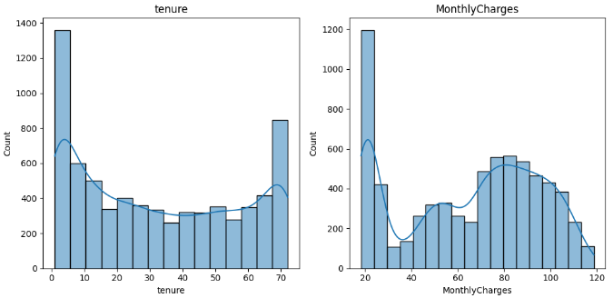
Figure 1: Tenure & MonthluCharges distribution
Business Context: Use this chart to show that our "Early Stage" customers are the most vulnerable.

3.2. Segment Vulnerability (Fiber Optic & Electronic Checks)
A critical discovery is that Fiber Optic users churn at a much higher rate than DSL users. Additionally, customers utilizing Electronic Checks as a payment method are significantly more likely to leave compared to those on automated credit card payments.
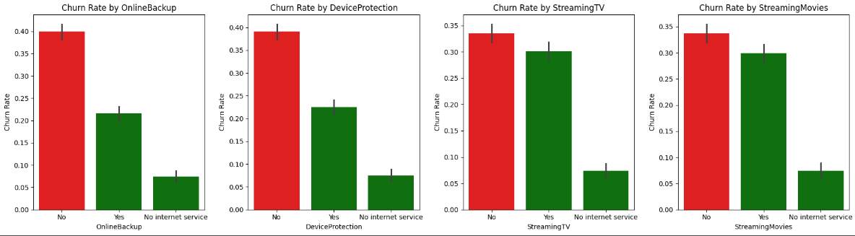
Figure 2: Churn by Services
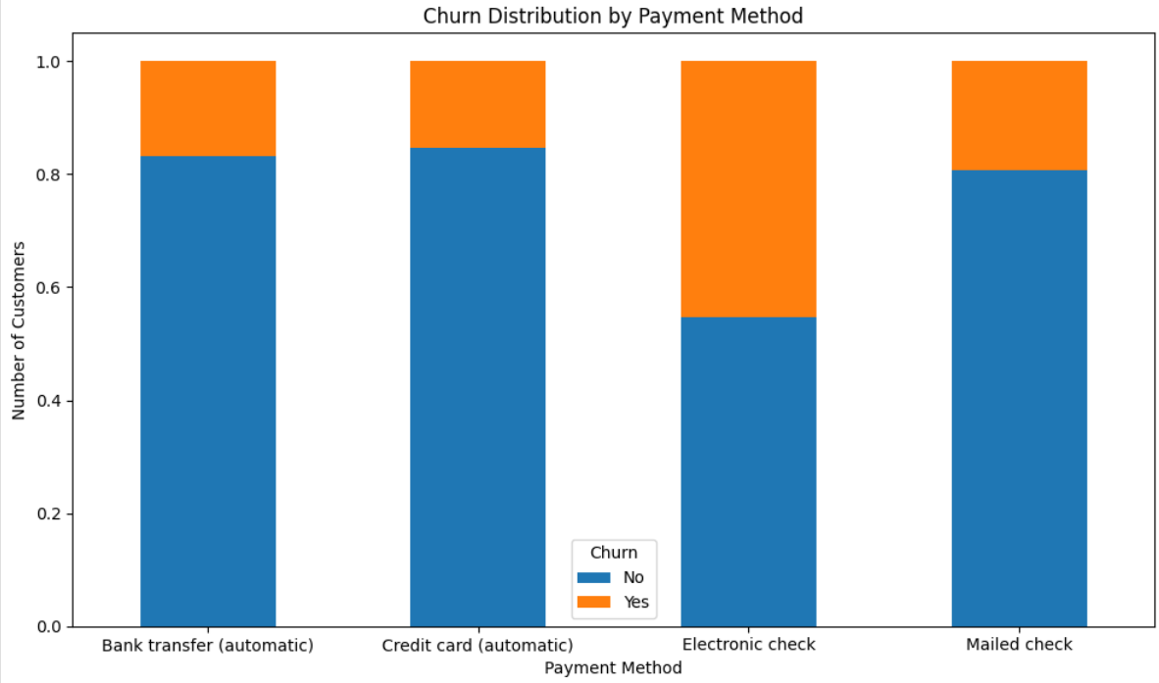
Figure 3: Churn by Payment Method
Business Context: This visual highlights that our premium service (Fiber) is underperforming in retention.

3.3. Contract Stability
Short-term commitments (Month-to-month) are the primary driver of churn. Customers on One-year or Two-year contracts demonstrate high loyalty and significantly lower attrition rates.

4. PREDICTIVE MODELING RESULTS
We successfully trained a Random Forest Model to predict the likelihood of a customer leaving.
- Model Performance: The model provides high sensitivity in detecting potential churners.
- Actionable Intelligence: We can now assign a "Risk Score" to every current customer.
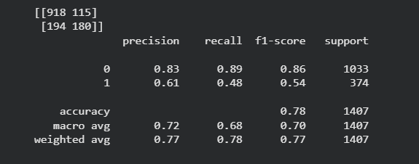
Figure 4: Confusion matrix of Random Forest model
- Business Context: This matrix proves the model's accuracy. It shows how many "At-risk" customers we can correctly identify for marketing intervention.

5. STRATEGIC DRIVERS (Priority Matrix)
The following factors have the highest impact on the model's decision-making process. Addressing these will yield the highest Return on Investment (ROI).
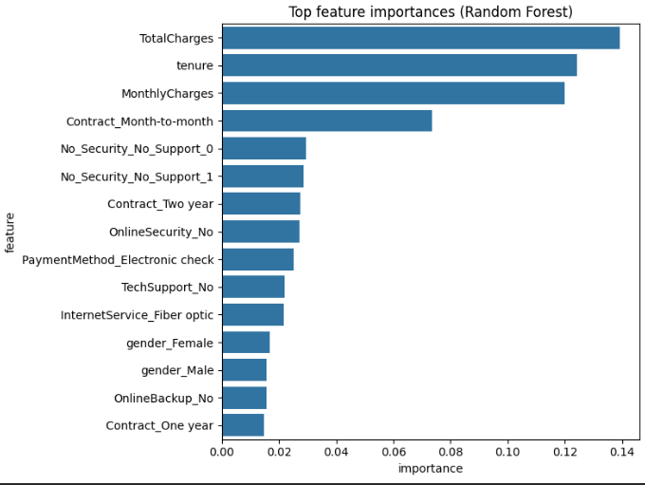
Figure 5: Top feature importance
Business Context: This chart ranks exactly what we should fix first. Contract Type, Tenure, and Monthly Charges are the top 3 priorities.

6. STRATEGIC RECOMMENDATIONS
Contract Conversion Incentive: Launch a campaign targeting "Month-to-month" users to switch to "1-Year Contracts" by offering a one-time 15% discount or a loyalty bonus.
Fiber Optic Service Audit: Investigate the high churn in Fiber Optic users. Is it due to pricing or technical stability? A quality-of-service audit is required.
Payment Method Migration: Incentivize customers to move from "Electronic Check" to "Auto-pay (Credit Card)" via a small bill credit. Automated payments typically increase customer "stickiness."
Early-Tenure Engagement: Create a "New Customer Success" program for users in their first 6 months to ensure they are utilizing all service features.

7. LIMITATIONS & FUTURE SCOPE
Data Source: This analysis is based on historical snapshots.
Next Steps: Integration of real-time usage data (e.g., data consumption patterns) would further improve the model's accuracy.

